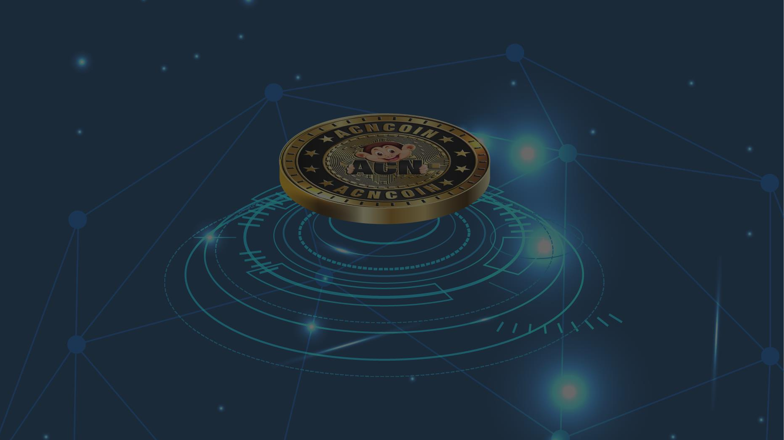

## ACNCOIN WHITEPAPER

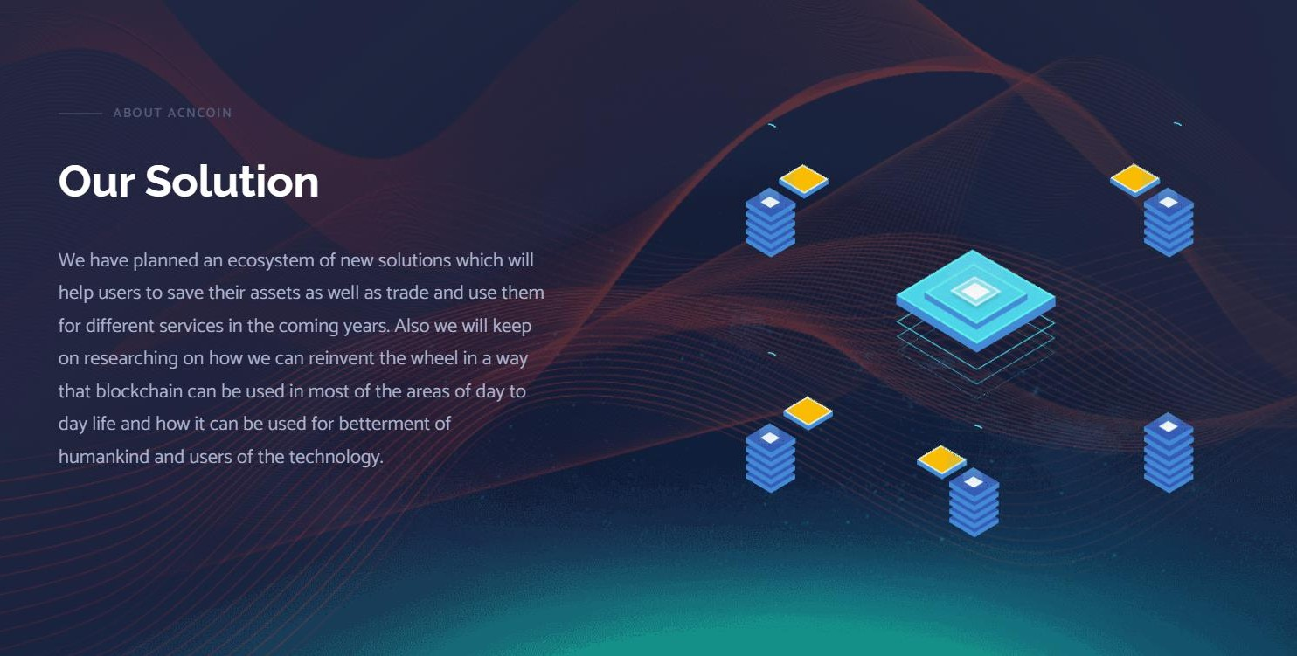

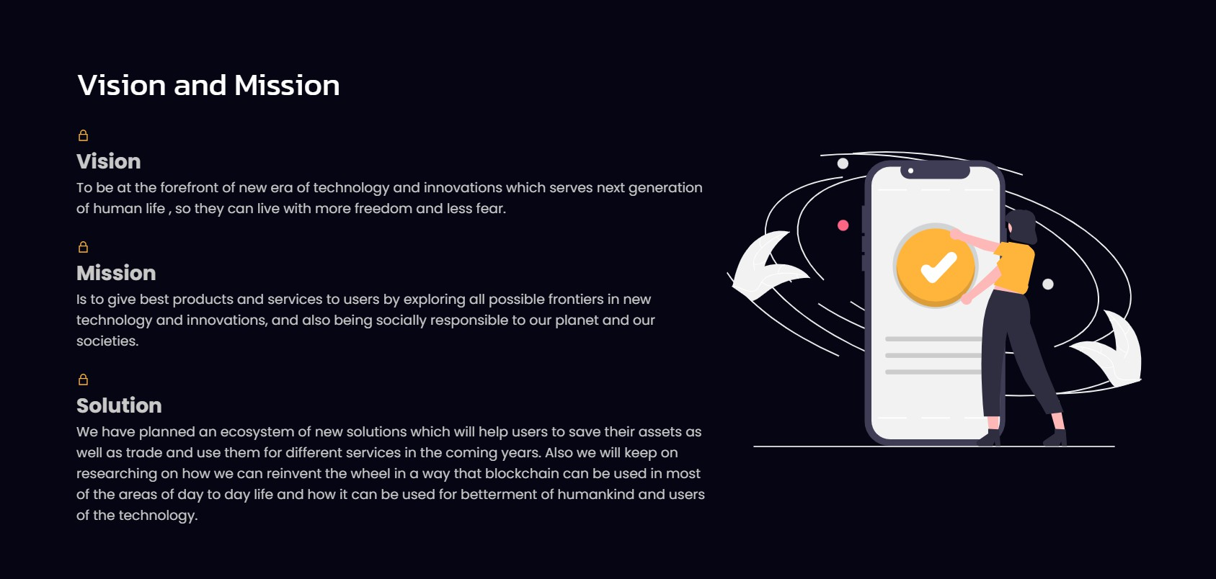

**HOW TO BUY ACN**

#### 2. Deposit Coins

Add BNB Chain to metamask / Trustwallet and Deposit BNB to your wallet.

#### 4. Unlock Your ACN

When you buy ACN, it will be held in the smart contract and you will be able to unlock when the sale is over. i.e unlock form will pop up when the sale ends

#### 1. Download metamask

You can download metamask wallet from metamask.io or you downlond trustwallet.com

#### 3. Buy ACN Tokens

Connect your wallet to our website and buy ACN

#### Congratulations

You Have successfully purchased ACNCoin.

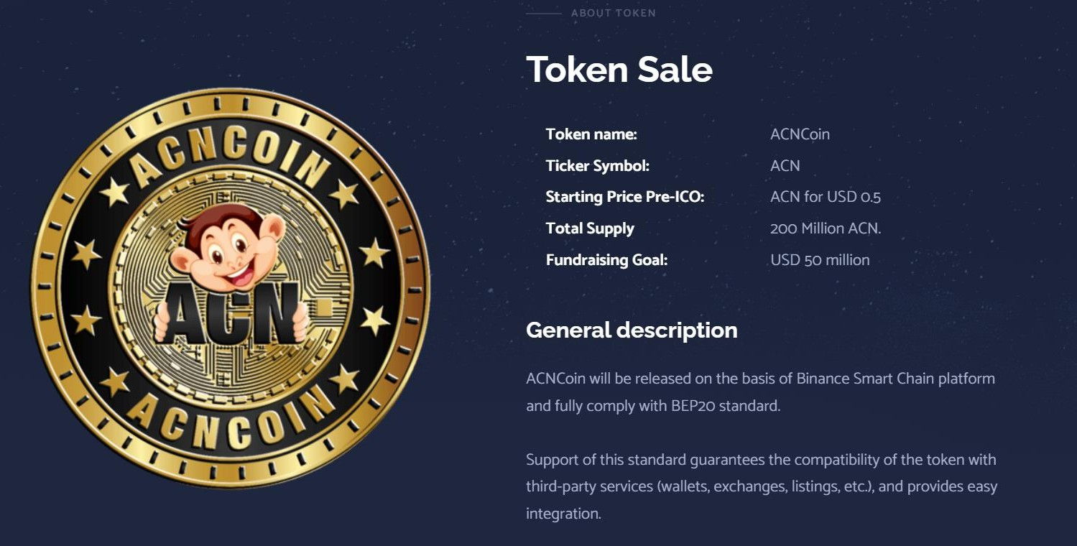

**Contract Address** 0xab87c0179c186C803cB50A92221EfEB23e4b83E9

**Presale Contract** 0x29367a6d16F1c0f8320A466D2f24e1971045757B

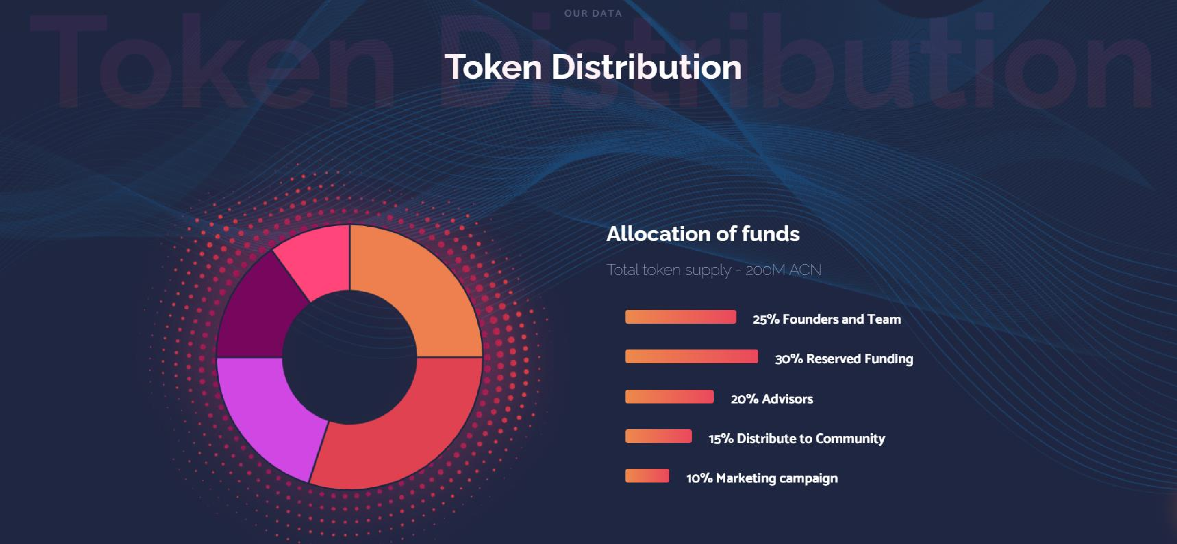

## CAPITALIZATION

1,000,000

900,000

800,000

700,000

600,000

500,000

400,000

300,000

200,000

100,000

Crypto Coin

## Capitalization



Lorem ipsum dolor sit amet, consectetur adipiscing elit, sed do eiusmod tempor incididunt ut labore et dolore magna aliqua. Ut enim ad minim veniam, quis nostrud exercitation ullamco laboris nisi ut aliquip ex ea commodo consequat.

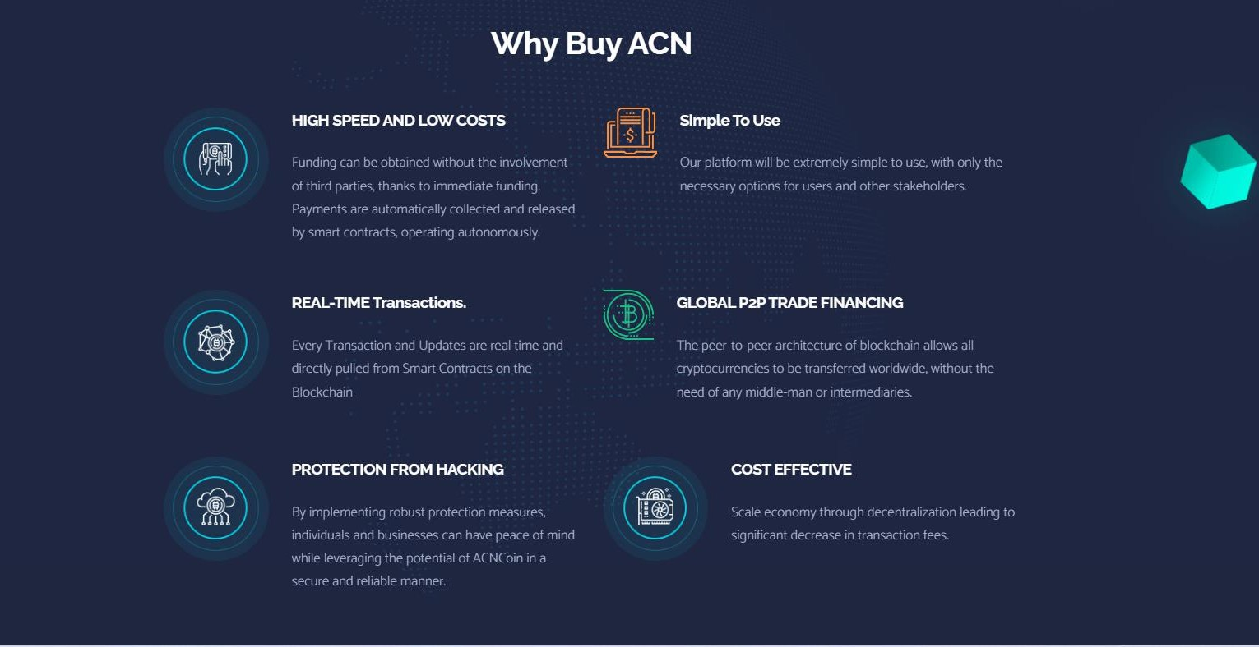

**OUR SERVICES**

# 01 03 04

**Popular**

**02**

**Service Two**

Lorem ipsum dolor sit amet, consectetuer adipiscing elit. Aenean commodo ligula eget dolor. Aenean massa.

**Service One**

**Service Three**

**Service Four**

Lorem ipsum dolor sit amet, consectetuer adipiscing elit. Aenean commodo ligula eget dolor. Aenean massa.

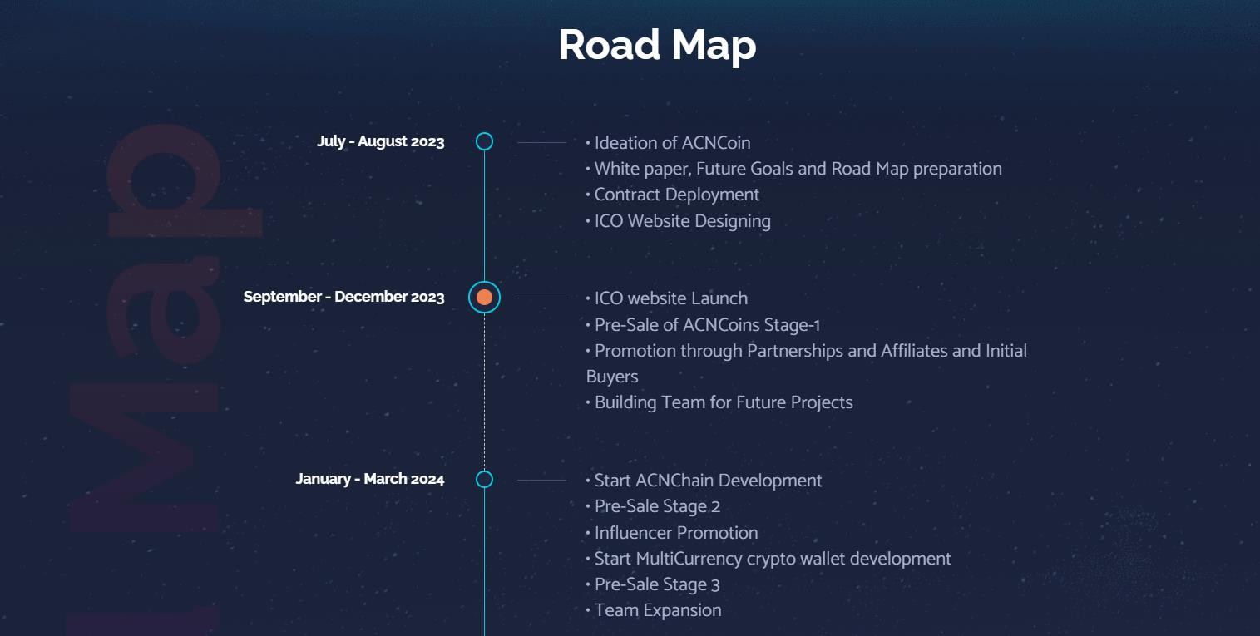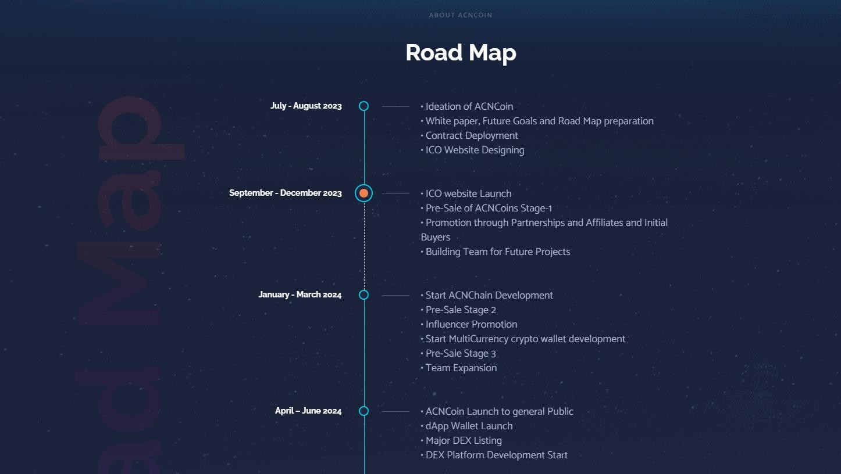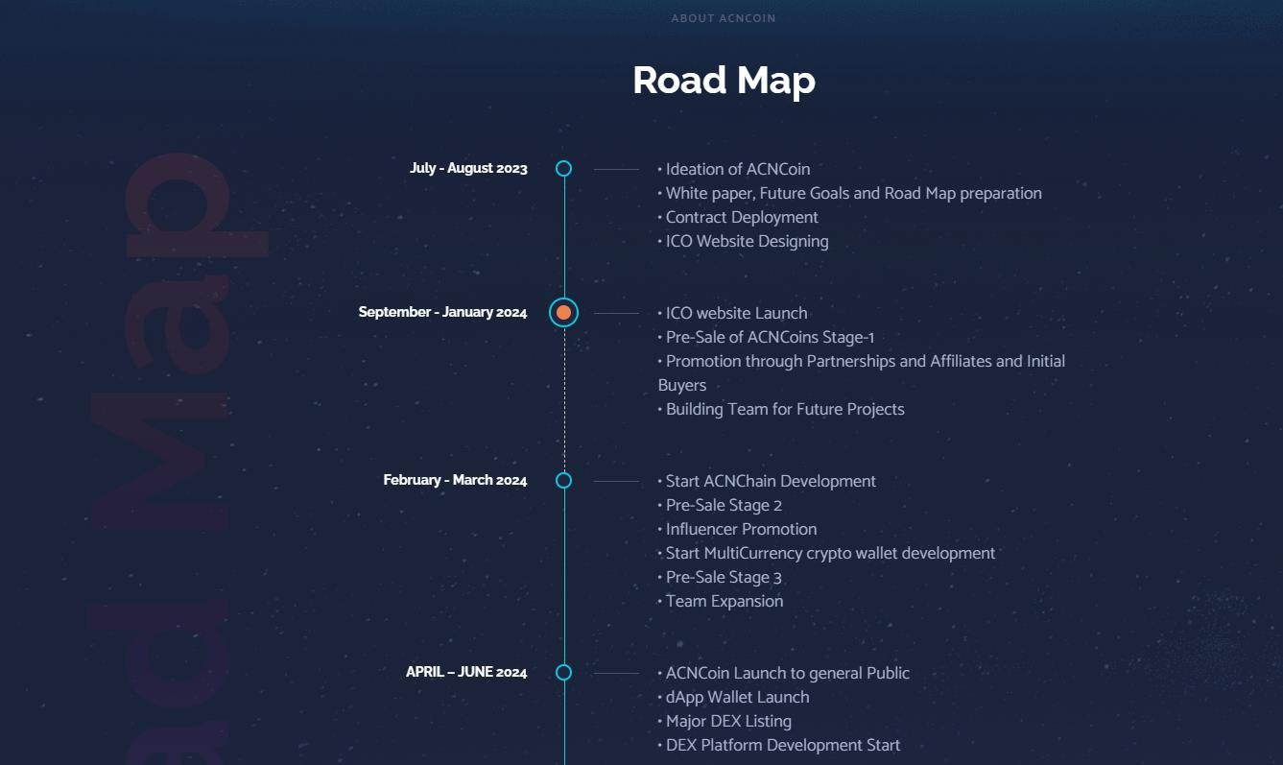

Lorem ipsum dolor sit amet, consectetuer adipiscing elit. Aenean commodo ligula eget dolor. Aenean massa.

Lorem ipsum dolor sit amet, consectetuer adipiscing elit. Aenean commodo ligula eget dolor. Aenean massa.

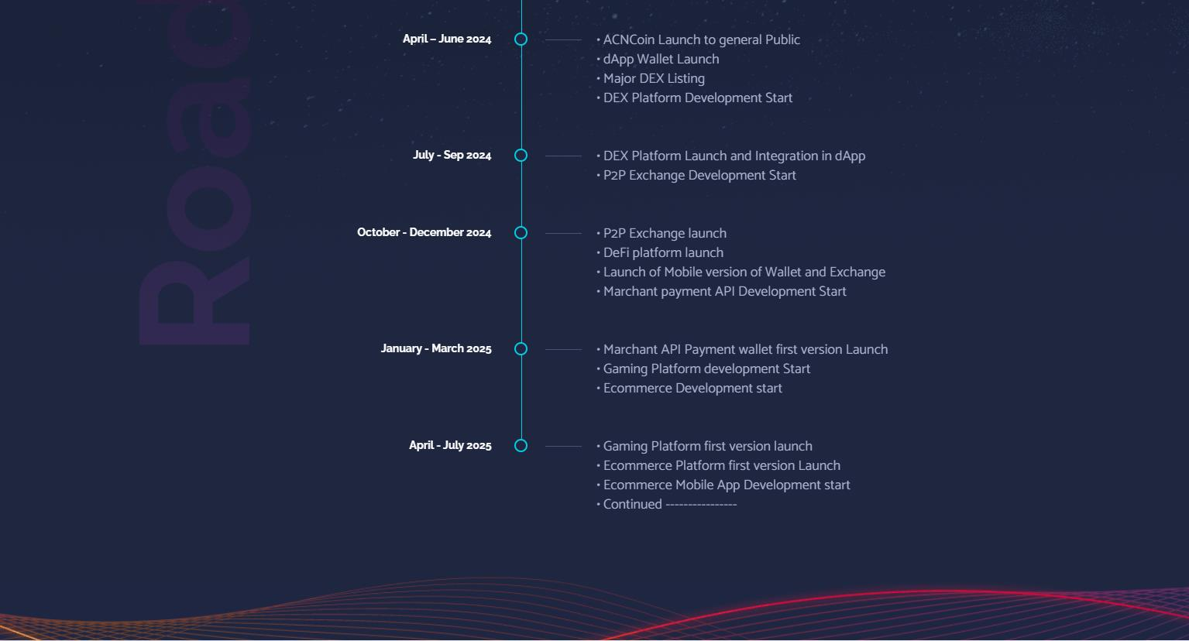

## Contact us

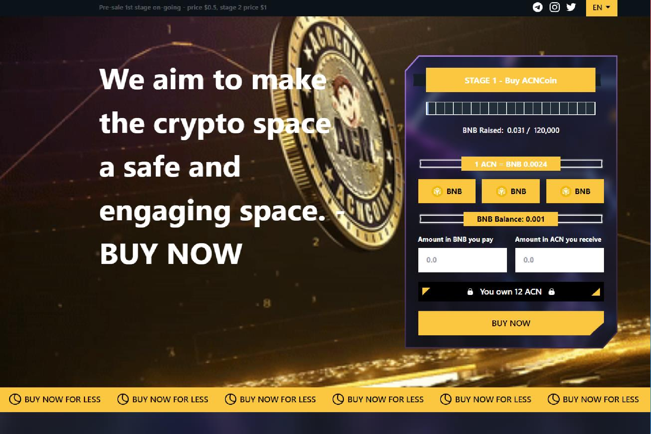

Get in touch



Website : [www.acncoin.com](http://www.acncoin.com/) Email : [info@acncoin.com](mailto:info@acncoin.com)

Telegram : <https://t.me/acncoinofficial>

### Smart Contract :

0xab87c0179c186C803cB50A92221EfEB23e4b83E9

### Presale Contract

0x29367a6d16F1c0f8320A466D2f24e1971045757B

## DISCLAIMER

Please read the following carefully.

Below applies to everyone who reads this white paper. The ACNCoin White Paper (hereinafter referred to as the "White Paper") is prepared and provided on the basis at the time of its preparation, so any content contained in the White Paper may be changed or updated at any time at the discretion of ACNCoin (hereinafter referred to as “The Company").

If you have any doubt on the content of this White, you should consult with your lawyer

1. The purpose of this white paper is to address summarized information and introductions about the ACNCoin platform the company is preparing. This white paper is not legally binding on the ACNCoin platform or company and does not have the nature of subscription, purchase, investment offers and investment enforcement.
2. All information or analysis in this white paper cannot be the basis for investment decisions and in no way constitutes investment proposal or advice.

We would like to inform you that any future-planned content or data in this White Paper may be changed for any reason.

1. Companies, including directors, agents, employees, contractors, and sales partners, are not liable for all kinds of damages that may occur directly or indirectly in accordance with the information contained in this document:

(1) accuracy and completeness of the contract;

(2) white paper error or omission;

(4) White paper unavailable. In addition, a company shall not be held solely responsible for any of the following consequences of a decision-making action using the information contained in this document:

(1) revenue, revenue, liabilities and all other forms of financial damage.

1. The content of the White Paper may vary depending on the ongoing ACNCoin platform, market changes, technological advances, and changes in ICO or token regulations. However, we inform you that the Company is not obliged to notify or report future events, platforms, future plans, changes in estimates or changes within the margin of error, etc. set forth in this white paper.
2. Information on areas such as law, tax, regulation, finance, and accounting in this white paper is not advice. Purchases of ACNCoins can result in material losses, including material assets paid to the buyer to purchase the ACN.
3. Inevitable risk: ACN platform is still under development and the company will try to develop and maintain ACN as stated in the white paper, but changes can occur for a variety of reasons, including legal, design, technology, and administrative regulations. Companies are exempt from liability for damages to value, loss and liquidity of ACNCoins due to force outside of the Company's control
4. Risks of change in value: the company does not guarantee the value of ACNCoins. The company may take relevant measures, such as changes in the value of ACNCoins, incineration, and so on, due to management or platform operational reasons. The company will be exempt from any damages caused by changes in the value of ACNCoins.

